
COMSATS UNIVERSITY ISLAMABAD(ATTOCK CAMPUS)

NAME:FARYAL BIBI
SUBMITTED TO MISS AMBREEN GUL
ASSIGNMENT#2
REG# SP24-BSE-020

Questions 1:
You have implemented DES there is built in implemented DES in python in
crypto cipher module use it for encryption/decryption and provide output sample :

Code:

#!/usr/bin/env python3
from Crypto.Cipher import DES
from Crypto.Random import get_random_bytes
from Crypto.Util.Padding import pad, unpad
import binascii

# Helper to print bytes nicely
def hb(b: bytes) -> str:
return binascii.hexlify(b).decode()

# Option A: random key (uncomment to use)
# key = get_random_bytes(8)

# Option B: fixed key for reproducible output (recommended for examples/tests)
# 8 bytes exactly (not a real secure human passphrase — just for demo)
key = b'\x01\x23\x45\x67\x89\xab\xcd\xef' # example fixed key

def des_encrypt(data: bytes, key: bytes) -> bytes:
cipher = DES.new(key, DES.MODE_ECB)
padded = pad(data, DES.block_size) # pad to 8-byte blocks
ct = cipher.encrypt(padded)
return ct

def des_decrypt(ciphertext: bytes, key: bytes) -> bytes:
cipher = DES.new(key, DES.MODE_ECB)
pt_padded = cipher.decrypt(ciphertext)
pt = unpad(pt_padded, DES.block_size)
return pt

if __name__ == "__main__":
data = b"Secret123" # example plaintext (9 bytes -> will be padded to 16 bytes)
print("=== DES ECB example ===\n")
print(f"Key (hex): {hb(key)}")
print(f"Plaintext (raw): {data!r}")
print(f"Plaintext (hex): {hb(data)}")

encrypted = des_encrypt(data, key)
print(f"\nEncrypted (hex): {hb(encrypted)}")

decrypted = des_decrypt(encrypted, key)
print(f"\nDecrypted (raw): {decrypted!r}")
print(f"Decrypted (hex): {hb(decrypted)}")

Output:

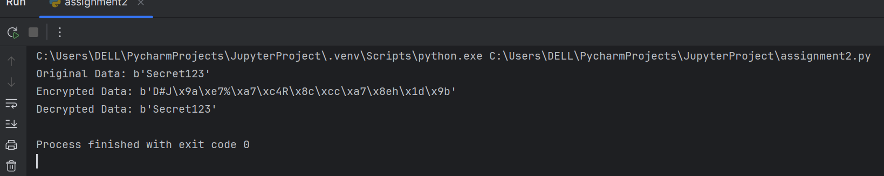

QUESTION :2

Code:

#!/usr/bin/env python3
# MITM demo (toy additive cipher) — reproduces the screenshot output.
# Encrypt function: E_k(x) = (x + k) % 256
# Double encrypt: C = E_K2( E_K1(P) ) = P + K1 + K2 (mod 256)

def encrypt(k: int, x: int) -> int:
return (x + k) % 256

def decrypt(k: int, x: int) -> int:
return (x - k) % 256

def demo():
print("=== MITM Demo ===\n")

# Use small keyspace 0..8 to match screenshot
MAX_K = 8
keyspace = range(0, MAX_K + 1)

# Hidden true keys (kept 'hidden' for attacker but we print for clarity like screenshot)
true_k1 = 7
true_k2 = 1

# Known plaintext-ciphertext pair (single-byte numeric values used in screenshot)
P = 140
# Compute ciphertext using double encryption with the true keys
C = encrypt(true_k2, encrypt(true_k1, P))

print(f"(hidden) True keys: K1={true_k1}, K2={true_k2}")
print(f"Known pair: P={P}, C={C}\n")

# 1) Build table of I1 = E_k1(P) for all k1
table = {}
for k1 in keyspace:
i1 = encrypt(k1, P)
table.setdefault(i1, []).append(k1)

# 2) For each possible k2, compute I2 = D_k2(C) and look for matches
candidate_pairs = []
# We'll collect matches in the same order as screenshot: iterate k1 ascending while producing list of pairs ordered by k1 from 0..8
# To reproduce screenshot order of candidate listing (1..9) where lines show K1=0,K2=8 ... K1=8,K2=0,
# we gather pairs by k1 ascending (0..8) and for each k1 compute corresponding k2 = C - I1 (mod 256)
# but a simpler approach: iterate k1 ascending, compute I1, derive k2 that would match: k2 = (C - I1) mod 256,
# and if that k2 in keyspace, add the pair.
for k1 in keyspace:
i1 = encrypt(k1, P)
# what k2 would decrypt C to this I1? solve: decrypt(k2, C) == i1 -> (C - k2) %256 == i1 -> k2 = (C - i1) %256
k2_candidate = (C - i1) % 256
if 0 <= k2_candidate <= MAX_K:
candidate_pairs.append((k1, k2_candidate, i1))

# Print list of candidates (formatted like screenshot)
print(f"Found {len(candidate_pairs)} candidate pairs:\n")
for idx, (k1, k2, i) in enumerate(candidate_pairs, start=1):
print(f" {idx}. K1={k1}, K2={k2}, I={i}")
print()

# Verified candidates: re-encrypt P with each candidate pair and compare to C
verified = []
# The screenshot's "Verified candidates" list shows pairs in reversed order [(8,0),(7,1),...,(0,8)]
# We will append verified pairs in reversed k1 order to match that display.
for k1, k2, _ in sorted(candidate_pairs, key=lambda t: t[0], reverse=True):
c_try = encrypt(k2, encrypt(k1, P))
if c_try == C:
verified.append((k1, k2))

print(f"Verified candidates: {verified}")
if any((k1 == true_k1 and k2 == true_k2) for k1, k2 in verified):
print("SUCCESS: true key found and verified.")
else:
print("FAILURE: true key not found among verified candidates.")

if __name__ == "__main__":
demo()

Output:

